Retail Sales Exploratory Data Analysis (SQL)

📑 Table of Contents
- Project Overview
- Business Problem
- Business Questions
- Dataset
- Database Tables
- Tools & Technologies
- SQL Concepts Demonstrated
- EDA Workflow
- Key Insights
- Skills Demonstrated
- Business Impact
- Executive Reporting
- Conclusion

📊 Project Overview
This project demonstrates a complete Exploratory Data Analysis (EDA) of a retail sales database using Microsoft SQL Server and T-SQL.
The objective was to transform raw transactional data into meaningful business insights by exploring:
- Customer purchasing behavior
- Product performance
- Sales trends
- Revenue generation
- Operational performance
The analysis was performed entirely in SQL using relational database principles, including joins, aggregate functions, window functions, subqueries, and date functions.
The project follows a structured EDA workflow that progresses from understanding the database structure to identifying actionable insights that support business decision-making.

💼 Business Problem
Retail businesses generate thousands of transactions every day. Without proper analysis, decision-makers can struggle to understand business performance and identify opportunities for improvement.
This analysis addresses questions such as:
- Which products generate the highest revenue?
- Which customers contribute the most sales?
- Which product categories are underperforming?
- What is the major customer purchasing trends?
- How are sales distributed across countries?
- What is the overall business performance?

🎯 Business Questions
The analysis was designed to answer the following questions:
- Which products generate the highest revenue?
- Which customers spend the most?
- Which product categories perform the best?
- Which gender contributes the most revenue?
- What is the average product cost by category?
- Which products perform the worst?
- How are sales distributed across different countries?
- What is the overall business KPIs?

🗄️ Dataset
The project uses a Star Schema consisting of:
- One fact table
- Two-dimension tables
The database structure supports analysis across customers, products, sales transactions, geography, and product categories.
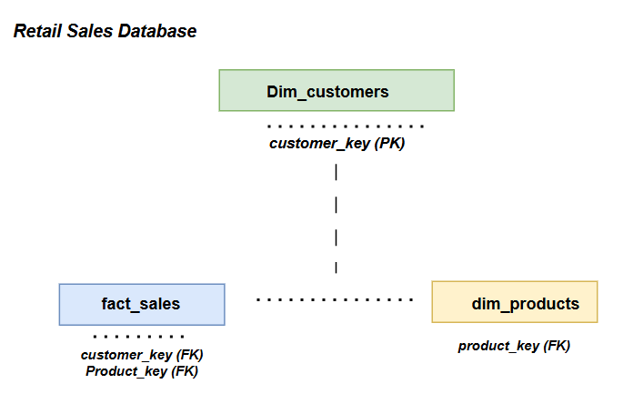

Entity Relationship Diagram ERD
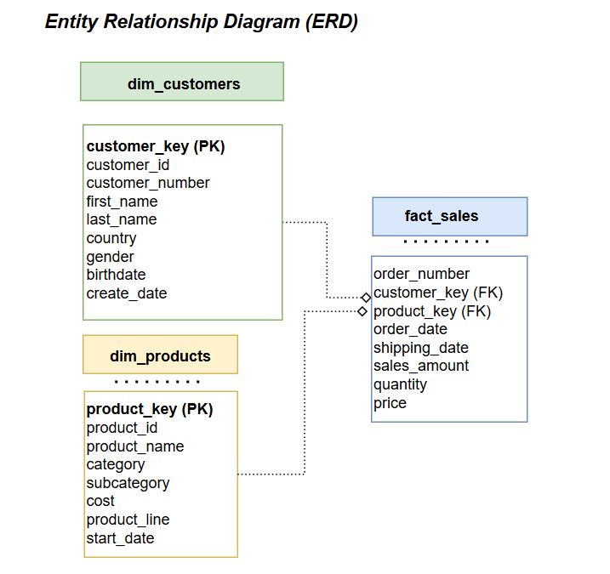

🗃️ Database Tables
The database consists of three related tables.

👥 Customers — gold.dim_customers
Column | Description
customer_key | Unique key identifying each customer
customer_id | Original customer identifier from the source system
customer_number | Business customer reference number
first_name | Customer first name
last_name | Customer surname
country | Country where the customer resides
marital_status | Customer marital status
gender | Customer gender
birthdate | Customer date of birth
create_date | Date the customer record was created

📦 Products — gold.dim_products
Column | Description
product_key | Unique product identifier
product_id | Product ID from source system
product_name | Name of product
category_id | Product category identifier
category | Main product category
subcategory | Product subgroup
maintenance | Indicates whether maintenance is required
cost | Product acquisition cost
product_line | Product family or business line
start_date | Date the product became available

🧾 Sales — gold.fact_sales
Column | Description
order_number | Unique sales order number
product_key | Foreign key referencing the Products table
customer_key | Foreign key referencing the Customers table
order_date | Date the order was placed
shipping_date | Date the order was shipped
sales_amount | Total revenue generated by the transaction
quantity | Number of units sold
price | Selling price per unit

🛠️ Tools & Technologies
- Microsoft SQL Server
- SQL Server Management Studio (SSMS)
- T-SQL
- GitHub

🧠 SQL Concepts Demonstrated
SQL Concept | Application
SELECT | Data retrieval
Filtering | Data selection and analysis
GROUP BY | Aggregation and summarization
ORDER BY | Sorting analytical results
Aggregate Functions | SUM(), COUNT(), AVG(), MIN(), MAX()
LEFT JOIN | Combining related datasets
INNER JOIN | Joining matching records
Window Functions | Advanced analytical calculations
ROW_NUMBER() | Ranking records
Subqueries | Nested analytical logic
Date Functions | Time-based analysis
UNION ALL | Combining result sets

🔍 Exploratory Data Analysis Workflow
The EDA process followed a structured analytical workflow:
Database Exploration → Dimension Exploration → Date Exploration → KPI Measure Exploration → Magnitude Analysis → Top N / Bottom Analysis

1. 🗄️ Database Exploration
The first stage focused on understanding the database structure.
Activities included:
- Exploring available tables
- Inspecting metadata
- Reviewing the database schema

2. 🌍 Dimension Exploration
The analysis explored key business dimensions, including:
- Customer countries
- Product categories
- Product hierarchy
- Product lines
This provided an understanding of the structure and distribution of the underlying business data.

3. 📅 Date Exploration
Date analysis was performed to understand the temporal characteristics of the dataset.
Key areas included:
- First order date
- Last order date
- Sales duration
- Youngest customer
- Oldest customer

4. 📊 KPI Measure Exploration
Core business KPIs were generated to establish an overall view of business performance.

Core KPIs
- Total Sales
- Total Orders
- Total Quantity Sold
- Average Selling Price
- Total Customers
- Total Products

5. 📈 Magnitude Analysis
Magnitude analysis examined the scale and distribution of key business measures
The analysis included:
- Customers by category
- Customers by gender
- Products by category
- Revenue by category
- Average cost by category
- Revenue by customer

6. 🏆 Top N & Bottom Analysis
The analysis identified the strongest and weakest performers

Analysis Areas
- Top 5 revenue-producing products
- Bottom-performing products
- Top 10 customers
- Lowest-ordering customers
- Best-performing product categories

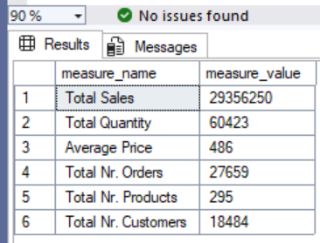
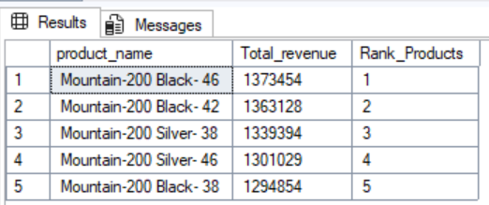
This allowed the business to identify high-value opportunities as well as areas requiring further investigation.

🔑 Key Insights
The analysis produced several notable findings:
- Bike generated the highest overall revenue.
- Mountain – 200 Series was the highest-performing product line.
- Female customers generated slightly higher revenue than male customers.
- The United States represented the largest customer market by units sold.
- Bike products had the highest average production cost.
- Racing Socks generated the lowest revenue among all products.
- A relatively small number of customers contributed a significant portion of total revenue, highlighting opportunities for customer segmentation and loyalty initiatives.

🧠 Skills Demonstrated
This project demonstrates the following technical and analytical capabilities:
- SQL Programming
- Exploratory Data Analysis
- Data Cleaning
- Relational Database Analysis
- Data Aggregation
- Customer Analytics
- Product Performance Analysis
- Business Intelligence
- KPI Development
- Data Storytelling

💼 Business Impact
The analysis provides insights that can support several areas of business decision-making.

💰 Revenue Optimization
- Identify the highest-performing products and categories for inventory prioritization.
- Focus marketing investment on profitable product lines.

👥 Customer Analytics
- Identify high-value customers for loyalty and retention campaigns.
- Understand customer purchasing behavior across countries and demographics.

📦 Inventory Management
Identify slow-moving products that may require:
- Discounts
- Promotional campaigns
- Pricing adjustments
- Product discontinuation
These actions can help reduce inventory carrying costs.

🌍 Geographic Expansion
Identify countries contributing the highest sales to:
- Allocate marketing resources more effectively.
- Identify potential geographic expansion opportunities.

📊 Product Portfolio Optimization
Compare product categories based on revenue and cost to support improved product-mix decisions and profitability.

📋 Executive Reporting
The analysis produces reusable SQL queries that can serve as a foundation for:
- Automated dashboards
- Business Intelligence reporting
- KPI monitoring
- Customer analytics
- Product performance reporting
This extends the project beyond exploratory analysis by creating analytical outputs that can be incorporated into downstream reporting solutions.

🏁 Conclusion
This project demonstrates how SQL can be used to transform raw transactional data into meaningful Business Intelligence.
By applying:
- Exploratory Data Analysis
- Relational database principles
- SQL aggregation
- Joins
- Window functions
- Subqueries
- Date analysis
- KPI development
the analysis uncovers customer purchasing behavior, product performance, and sales trends that support data-driven business decision-making.

⭐ Portfolio Takeaway
Raw Transactional Data → SQL EDA → KPI Analysis → Customer & Product Insights → Business Recommendations
This project demonstrates the ability to move from raw relational data to structured analysis and actionable Business Intelligence insights

